 **BAHRIA UNIVERSITY (KARACHI CAMPUS)**

**ASSIGNMENT # 1 - FALL 2020**

# Operating Systems (CSC-320)

Class: **BSE 4 A&B** Submission Deadline: **17/18 March, 2020**

Course Instructor: **Dr. Osama Rehman**

Lab Instructor: **Engr. Fareeha Dilawar** Max Marks: **10**

Student’s Name: **Syed Ali Abbas**

1. Study and implement pipes in Linux. List down three examples with outputs attached in the screenshots.

**Example: 1**

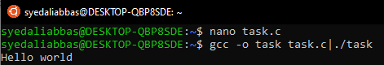

**Example: 2**

**Input**

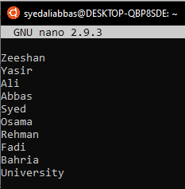

**Output**

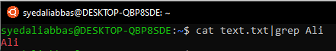

**Example: 3**

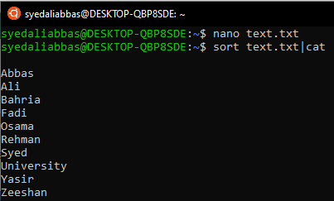

1. Write a C program that asks users to provide an integer input in the main() function. The program would call a function even_odd() from the main() function, where the function even_odd()accepts an integer as an argument, determine and display if the passed integer is either even or odd.

**Input:**

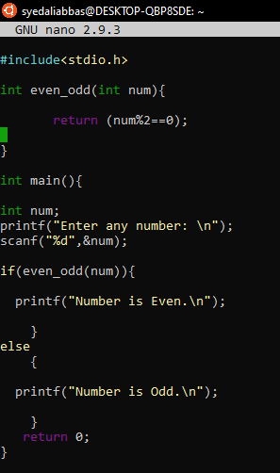

**Output:**

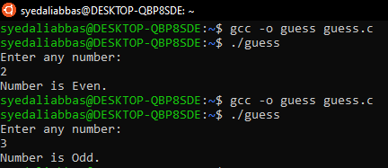

1. Study and implement system calls in Linux. List down three examples with output screenshot attached.

**Example: 1**

**Input:**

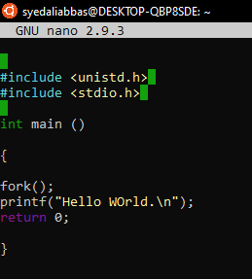

**Output:**

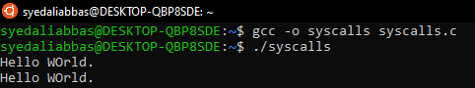

**Example: 2**

**Input:**

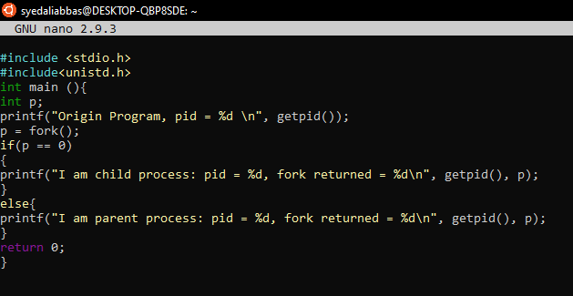

**Output:**

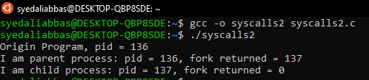

**Example: 3**

**Input:**

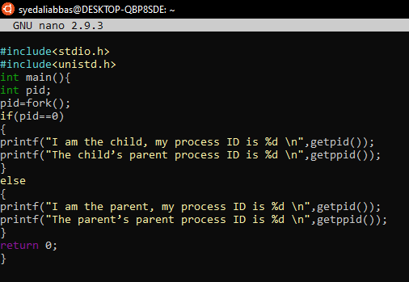

**Output:**

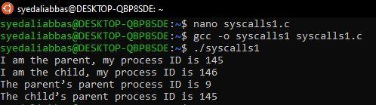

1. Learn and implement First Come First Serve (FCFS) scheduling algorithm in C language.

**Input:**

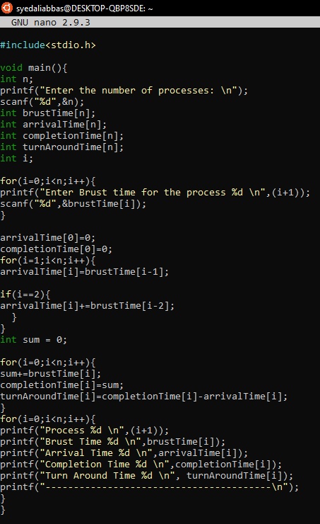

**Output:**

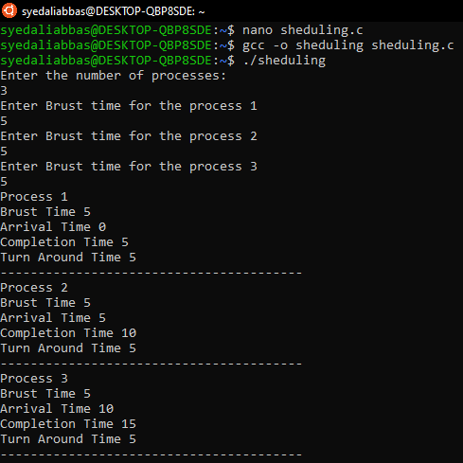

1. Think and propose two projects that can be delivered as the final lab projects in Operating Systems lab. The ideas must be valid and should be explained with research topics and examples.

* **USB Device Driver**

USB Device Driver project aims to develop a device driver for USB interface devices implementing all basic operations that can be performed with a USB such as reading, writing and transferring data between two Environments.

We will create and implement our own USB Device Driver in the Linux Environment using “Shell Scripting”. The USB client driver or the USB class-specific driver is loaded when the operating system first detects the corresponding class-specific device. It remains loaded until the last device of the corresponding class is removed from the system.

USB Device Driver will have the following functionalities:

1. **USB Functions :**

The USB - Driver adds its functions to the kernel device .It registers with the USB system driver (USBD) to determine whether the device is attached and configured .Other functionalities include reading, writing and transferring data from USB – Storage Device.

1. **Device Recognition :**

On attachment, the driver must be able to make the device ready to use.

* **Tic Tac Toe**

Tic-Tac-Toe is a two player game where each player uses a signature.  The player who successfully places three respective signatures in a vertical, horizontal or diagonal row is the winner.  
**Step 1:** Use 3 X 3 matrix to get 9 cell tic tac toe board.  
**Step 2:** Signature 'X' is used for player 1 and 'Y' for player 2.  And the players play  
           alternatively.  
**Step 3:** Get index as input from the players.  And the index range is 1-9. i.e) from   
           cell 1 to cell 9.  
**Step 4:** After each move, check whether that player has placed three respective  
           signatures in vertical, horizontal or diagonal row.  If yes, declare that  
           particular player as winner.  
**Step 5:** If no, give chance for other player.  
**Step 6:** If all the cells in the Tic-Tac-Toe board got filled, then the game is drawn.

This game will be implemented on c language.

Take **Note**:

* If you submit your assignment after the given deadline then **2 Marks** will be deducted for the late submissions.
* Copied assignment will be marked **zero (means zero plagiarism)**.

If you have any query, feel free to contact at: fareeha1810@yahoo.com